**FlyAway**

(Documentation)

Project Name:- FlyAway

Project Developer :- Priya Naveen

Objectives of Project:-

* A search form in the homepage to allow entry of travel details, like the date of travel,source, destination, and the number of persons.
* Based on the travel details entered, it will show the available flights with their ticket prices.
* Once a person selects a flight to book, they will be taken to a register page where they must fill in their personal details. In the next page, they are shown the flight details of the flight that they are booking, and the payment is done via a dummy payment gateway. On completion of the payment, they are shown a confirmation page with the details of the booking. For the above features to work, there will be an admin backend with the following features:
* An admin login page where the admin can change the password after login, if he wishes
* A master list of places for source and destination
* A master list of airlines
* A list of flights where each flight has a source, destination, airline, and ticket price

Sprint

One sprint taken

And its time period is 3 weeks 15 worling days

|  |  |
| --- | --- |
| ConFig | Value |
| Sprint Start | 01/04/2022 |
| Sprint End | 20/04/2022 |
| Daily Hours | 9 |
| Focus Factor | 95% |
| No. Weeks | 3 |
| Working Days | 15 |
| Work Hours | 135 |
| Available WH | 99 |

|  |  |  |
| --- | --- | --- |
| Name | Role | Contribution |
| Priya Naveen | FSD | 100% |
| Priya Naveen | QA | 100% |
| Priya Naveen |  |  |

|  |  |  |  |  |
| --- | --- | --- | --- | --- |
| Story Name | Story Points | Hours For Fed | Hours For Bed | Hours For QA |
| As the Hr Manager I want | 13 | 30 | 2 | 22 |
| As a Manager | 13 | 70 |  |  |
| As a User | 8 |  | 2 | 20 |

Features :-

* An admin login page where the admin can change the password after login, if he wishes
* A master list of places for source and destination
* A master list of airlines
* A list of flights where each flight has a source, destination, airline, and ticket price

Algorithm:-

Step1:- Start

Step2:- Create Dynamic web project.

Step3:- Create classses

Step4:- create Jsp

Step5:- create Servlets

Step6:-Go the File menu. Choose New->Dynamic Web Project

Step7:- Enter the project name as FlyAway. Click on Next

Step8:- Enter nothing in the next screen and click on Next

Step9:-Check the checkbox Generate web.xml deployment descriptor and click on Finish

Step10:- This will create the project files in the Project Explorer

Step11:- End

FlowChart:-

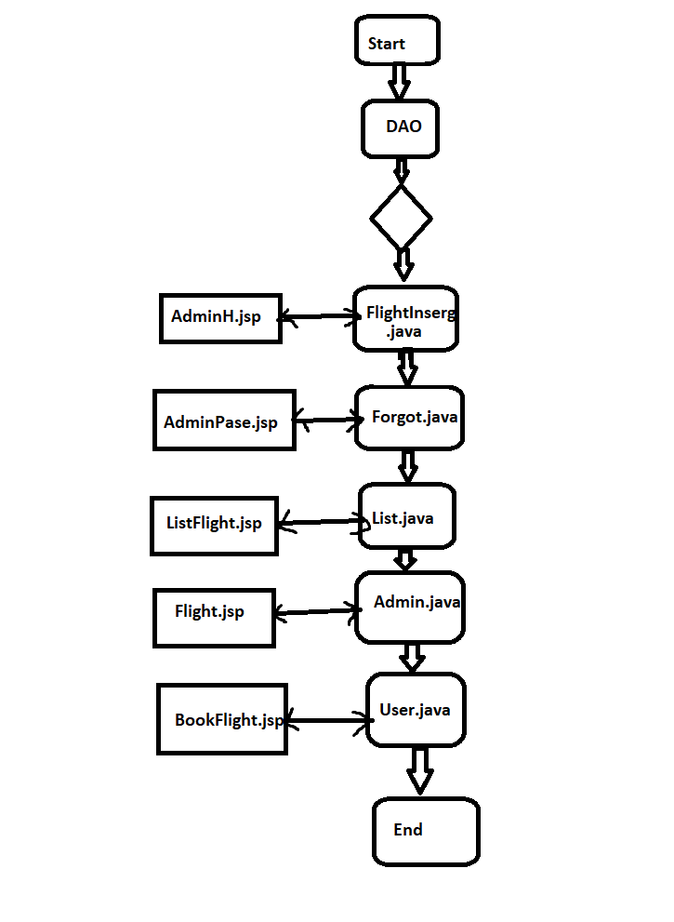

**Tools used for development**:

1. Eclipse IDE

2. MySQL Relation Database Management System

3. Apache Tom-Cat 10 server

4. Java Servlets

5. Java Server Pages (JSP)

6. HTML

7. Apache Maven

8. JDBC Java Database Connectivity

Step 1.1.1: Creating a dynamic web project

Unique selling Point:-

“Quality Matters here, The Next Quality”